Data Report

By Laura C. Larregui

Source of Data: FEMA. (2020). US Natural Disaster Declarations (Version 3) [CSV file]. Retrieved from https://www.kaggle.com/headsortails/us-natural-disaster-declarations.

Table of Contents

Data 2

Description 2

Data Set Calculation 2

str() Output 2

Descriptive Plots 3

Single-Dimension Plots 3

Multidimension Plot 6

# Data

## Description

This dataset includes a record for every federal emergency or disaster declared by the Federal Emergency Management Agency (FEMA) since 1953.

## Data Set Calculation

Calculation = (# of Columns * 4) / (# of Rows / 100) = (22*4)*(59181/100) = 52079.28

## str() Output

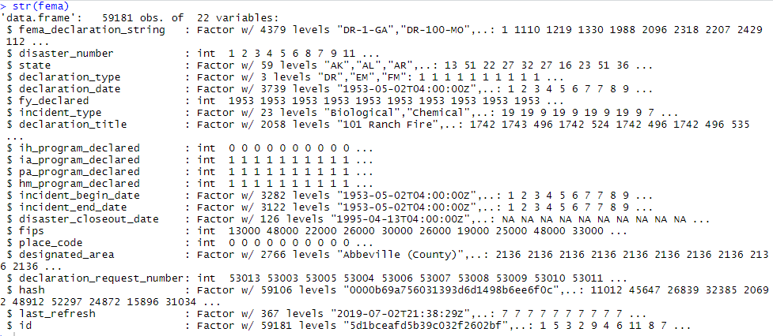

# Descriptive Plots

## Single-Dimension Plots

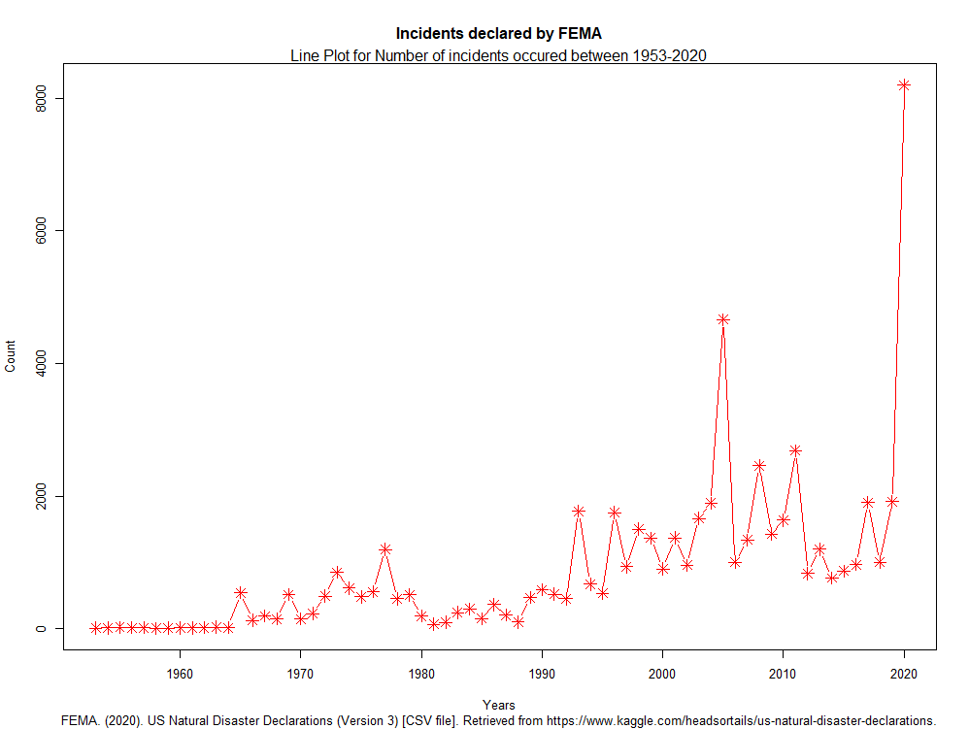

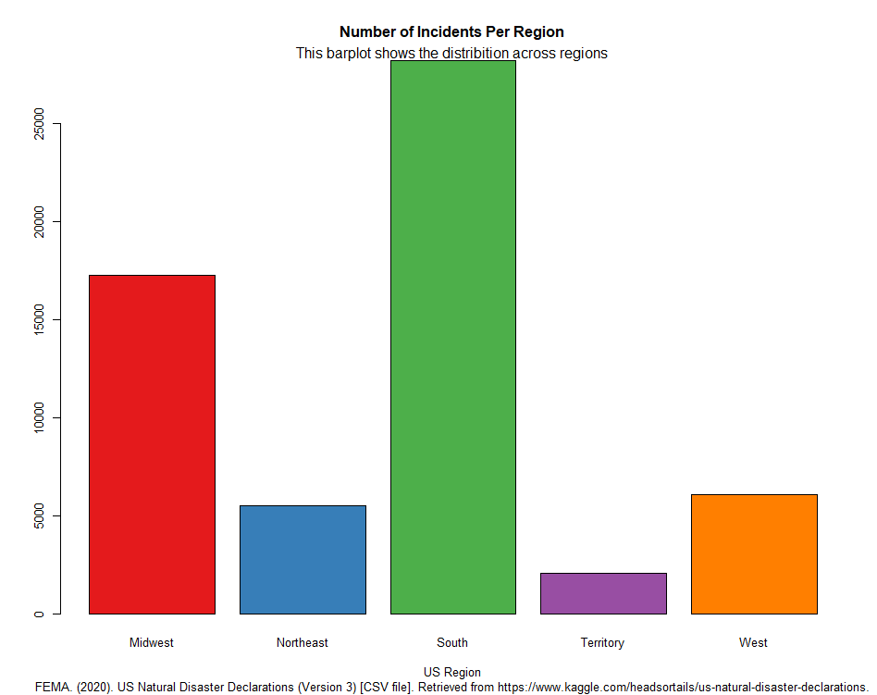

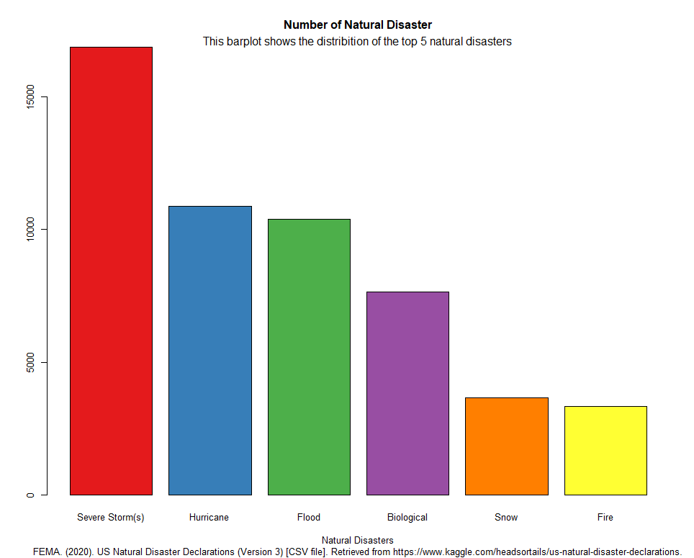

## Multidimension Plot

